English 3994 (Undergraduate Seminar) Tuesday 4:10-6:00 p.m.
607 Hamilton Hall
Prof. Joseph Albernaz (ja3309@columbia.edu)
Philosophy Hall 408b (Office Hours: TBD)

Syllabus: Romanticism and the Experience of Freedom (Fall 2021)

“What is Freedom? Ye can tell / That which slavery is, too well” –P.B. Shelley, “The Mask of Anarchy” (1819)

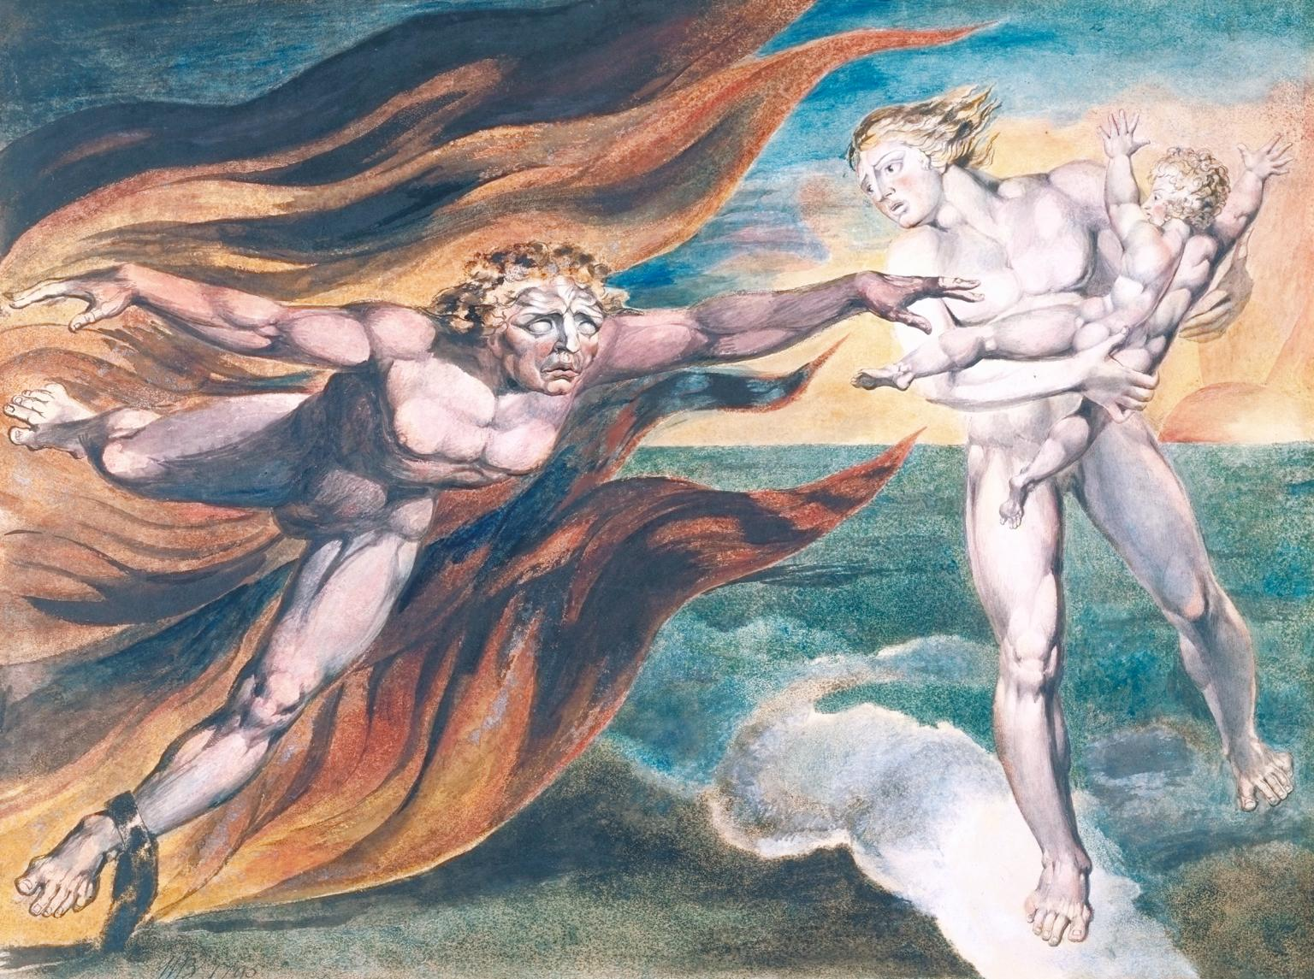

Description: “Freedom” was perhaps the central watchword of Romantic-era Britain, yet this concept remains exceedingly, notoriously difficult to pin down. Taking a cue from the sociologist and historian Orlando Patterson, who writes that “freedom is one those of values better experienced than defined,” this seminar will explore the variegated experiences of freedom and its opposites in the literature of British Romanticism. Romanticism unfolds alongside major revolutions in America, France, and Haiti, and we will begin by examining how the differing conceptions of freedom offered in the wake of these revolutions and their receptions galvanized writers and thinkers in Britain. From here, we will probe the expressions, possibilities, implications, and limits of freedom as outlined in various domains: political, individual, aesthetic, economic, philosophical, religious, and beyond. What does, say, Wordsworth’s claim to freedom to experiment in poetic form have to do with political and social freedom? In situating Romanticism alongside developments like revolution, the rise of globalization, and the Atlantic slave trade, we will be particularly interested in confronting how the explosion of claims to freedom in this period emerges together with and in response to the proliferation of enslaved, colonized, and otherwise constrained or hindered bodies.

As we read poems, novels, slave narratives, philosophical essays, political tracts and documents, and more, a fundamental question for the course will concern the relation between binary terms: to what extent, and how, do notions of freedom in Romanticism depend on the necessary exclusion of the unfree? Since the Romantic age sees the birth of concepts of freedom still prevalent in our own day, this course will offer an opportunity to reflect critically on the present. To that end, we will take up some contemporary theoretical analyses and critiques of freedom, both directly in relation to Romanticism and reaching beyond.

Texts (available at Book Culture, 112th street):
Ottobah Cugoano - Thoughts and Sentiments on the Evil of Slavery (1787) (Penguin)
Mary Shelley – Frankenstein (1818 text) (Oxford)
Mary Wollstonecraft – Letters written in Sweden, Norway, and Denmark (1796) (Oxford)
William Wordsworth – Major Works (Oxford)
William Blake – Blake’s Poetry and Designs (Second Edition) (Norton)

Various PDFs and texts on Courseworks

Grading and Requirements:
Short Paper (4 pgs) - 15%
Midterm – 25%
Final Paper – (10-12 pgs) 35%
Attendance, Reading, and Participation (including posts) – 25%

Schedule:

Week 1: Tue., Sep. 14
Selections from Locke, Rousseau, Constant
Orlando Patterson – “Preface,” “The Meaning of Freedom,” and “Coda” from Freedom in the Making of Western Culture
Hannah Arendt - “What is Freedom?”
Week 2: Tue., Sep. 21
American Declaration of Independence (1776), French Declarations Rights of Man and Citizen (1789, 1793), Haitian Declaration of Independence (1804) and Constitution of Hayti (1805)
Olympe de Gouges – “Declaration of the Rights of Woman and Citizen” (1791)
Toussaint Louverture – Selected Writings

Guest lecture: Dr. Catarina von Wedemeyer on Olympe de Gouges

*optional reading:
Isaiah Berlin – “Two Concepts of Liberty”
Sibylle Fischer – from Modernity Disavowed: Haiti and the Cultures of Slavery in the Age of Revolution

Week 3: Tue., Sep. 28:
Ottobah Cugoano - Thoughts and Sentiments on the Evil of Slavery (1787)

Stefan Wheelock – Barbaric Culture and Black Critique (excerpt)
Stephen Best and Saidiya Hartman – “Fugitive Justice”
Week 4: Tue., Oct. 5:
William Blake – Selected Songs of Innocence and Experience, The Marriage of Heaven and Hell, “A Song to Liberty,” Visions of the Daughters of Albion, The Song of Los, Selected images and designs

Saree Makdisi – “William Blake and the Cultural Politics of Liberty in the 1790s”
Week 5: Tue., Oct. 12:
Blake continued
Week 6: Tue., Oct. 19:
Mary Wollstonecraft – Vindication of the Rights of Woman (1792) (selections) and Letters written in Sweden, Norway, and Denmark (1796)

*Short Paper (4 pages) Due
Week 7: Tue., Oct. 26:
Mary Shelley – Frankenstein; or the Modern Prometheus (1818)

Week 8: Tue., Nov. 2 – NO CLASS.

*Take-home mid-term
Week 9: Tue., Nov. 9:
Poetry of Abolition: Hannah More, Anna Barbauld, Robert Southey, et al.
Robert Wedderburn – The Axe Laid to the Root
Week 10: Tue., Nov. 16:
Samuel Taylor Coleridge – “The Rime of The Ancient Mariner,” “Lectures On the Slave Trade”
Neil Roberts – Freedom as Marronage (excerpt)
Week 11: Tue., Nov. 23:
William Wordsworth – Preface to Lyrical Ballads; Selections from The Prelude; “To Toussaint L’Ouverture,” “Nuns fret not,” etc.
Dorothy Wordsworth – “Thoughts on My Sick Bed”
Week 12: Tue., Nov. 30:
Week 13: Percy Shelley – The Mask of Anarchy, “England in 1819,” “Liberty,” “Ode to Liberty,” etc
*1 page final paper outline due December 1st.
Week 13 Tue., Dec. 7:
Freedom and its Critics Today: Selections from Jean-Luc Nancy, Saidiya Hartman, Frank Ruda, Fred Moten, et al.

December 13: *Final Paper (10-12 pages) due

--------------------------------------------------
Course Assignments:

In this class you will write two papers, a short 3-4 page close-reading paper and a final paper of 10-12 pages. After having the rough topic of your final paper approved by me, a one-page outline of the final paper, with a bibliography of 5 theoretical and secondary sources, will be due December 1st. There will also be a take home mid-term exam of 3-4 pages.

Course Policies and Information:

Attendance:
Since this is a discussion-based seminar meeting only once a week, attendance is crucial. Unexcused absences will affect your grade. Please contact me in advance about religious, medical, or other excused absences.

Participation:
In addition to regular and respectful participation in class discussion (and other ways of participating like suggesting connections to the class or to me through email, talking to me in office hours, etc.) you are required to post one paragraph length response to the readings on Courseworks by 10:00 pm Sunday night each week, ending with a substantive question for class discussion. Possible reading quizzes will may factor into your participation grade.

Laptops:
Please bring your book to class every meeting (or print out the required readings if posted). Laptops will generally not be permitted, unless you talk to me for approval.

Accommodations:
If you need disability-related accommodations in this class (with documents from the Office of Disability Services), if you have emergency medical information you wish to share with me, or if you need special arrangements in case the building must be evacuated, please inform me right away. Please see me privately after class or in my office, or send me an email.

Plagiarism:
Plagiarism (even unintentional) is an extremely serious offense and will not be tolerated. Feel free to come to me with questions on what is or isn’t plagiarism. If you aren’t sure, it’s always better to be safe and ask! Please consult Columbia’s handbook for more information on plagiarism.

